**Lab 1.2.1 Your first program**

Try to:

* add a greeting – let the program welcome you in a warm and pleasant way;duplicate (or triplicate) the greeting to welcome more than one person;
* insert a line saying cout << endl;
* between two other couts and check the effects it has;
* does it look interesting? You're going tolearn more about it soon;now try to insert a mysteriously-looking sequence of chars into any of the greeting: \n – there are exactly two characters: abackslash and lower-case n;
* what happens now?;
* try to remove any of the semicolons and look carefully at the compiler's response; pay attention to where the compiler sees an error – is this where the error really is? change the name of the main function to any other lexically correct word (e.g. Main);
* what happens now? Can you explain the result? remove some of the quotes (opening and closing ones respectively);
* does the compiler like that? What does it think of your actions?

**Code:**

#include <iostream>

using namespace std;

int main()

{

cout<<"Hi, it's me, your first programm :)";

cout<<endl;

cout<<"Hi, it's me, your first programm :)\n";

cout<<"Hi, it's me, your first programm :)";

return 0;

}

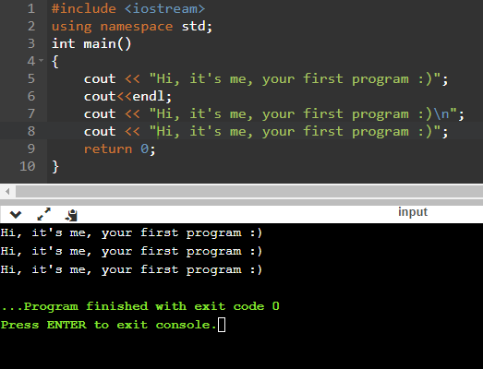

**Lab 1.3.1 Comments: are they always useful?**

Comments are not always the best way to say something in code. Try toimprove it (and remove the comments – removing the comments will sometimes be an improvement itself).

**Code:**

#include <iostream>

#include<iomanip>

using namespace std;

int main()

{

int v=10800;

int zzz1=3*60;

int zzz2=5*60;

float siii=3.141526;

cout<<"result: "<<v<<endl;

return 0;

}

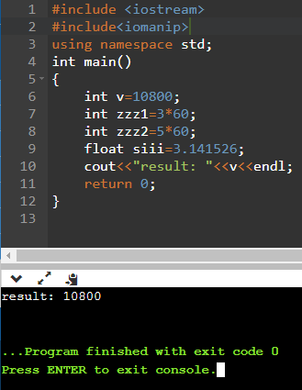

**Lab 1.4.1 Parentheses**

Add some parentheses (none, one or two pairs) in the code below to get the expected results. Try to do this before you run the program.

**Code:**

#include <iostream>

#include <iomanip>

#include<string>

using namespace std;

int main()

{

float v=2;

float result = (v + 1 ) * 2;

cout<<"result: " << result << " expected result : 6" <<endl;

result = (v + 1 ) *(v + 2 ) * 2;

cout<<"result: " << result << " expected result : 24" <<endl;

result = (v - 1 ) * 2 + 2 * 2;

cout<<"result: " << result << " expected result : 6" <<endl;

result = (v + v ) * (v + v ) * 2;

cout<<"result: " << result << " expected result : 32" <<endl;

result = (int)v % 2 * (v + 2 ) * 2;

cout<<"result: " << result << " expected result : 0" <<endl;

return 0;

}

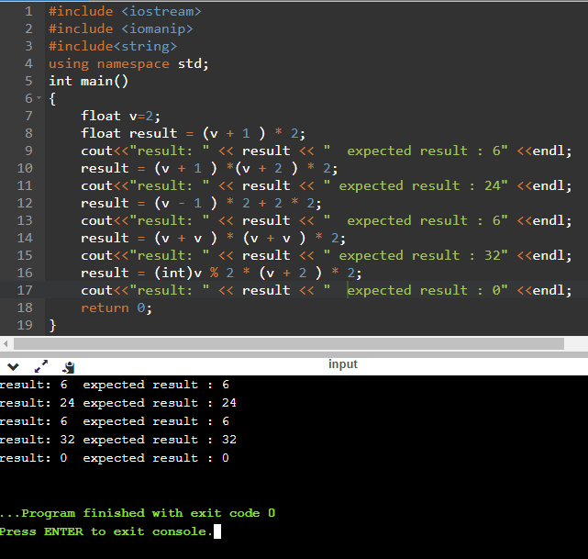

**Lab 1.4.1 Floats: operators and expressions**

Take a look at the code below: it reads a float value, puts it into a variable named x and prints the value of a variable named y. Your taskis to complete the code in order to evaluate the following expression:

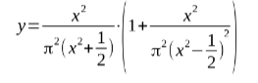

**Code:**

#include<iostream>

#include<cmath>

using namespace std;

int main(void)

{

float pi = 3.14159265359;

float x,y;

cout << "Enter value for x: ";

cin >> x;

y=((x*x)/((pi*pi)*((x*x)+0.5)))*(1+((x*x)/((pi*pi)*pow((x*x)-0.5,2))));

cout << "y = " << y;

return 0;

}

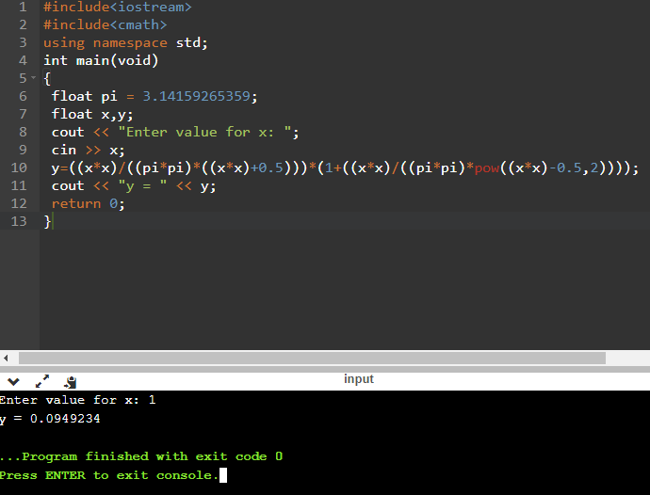

**Lab 1.4.2 Ints: operators and expressions**

Test your code using the data we've provided.

* increment i by 2
* decrement j by i
* divide i by j giving k
* increment k by k
* decrement k by 1
* assign k modulo i to j
* increment k by k added to i
* increment k by k divided by j
* assign k times k times k to k
* increment k by i times j

**Code:**

#include <iostream>

using namespace std;

int main(void) {

int i, j, k;

cout << "Enter i: ";

cin >> i;

cout << "Enter j: ";

cin >> j;

i += 2;

j -= i;

k= i / j;

k += k;

k --;

j= k % i;

k += (k + i);

k += k / j;

k = k*k*k;

k += i * j;

cout << k;

return 0;

}

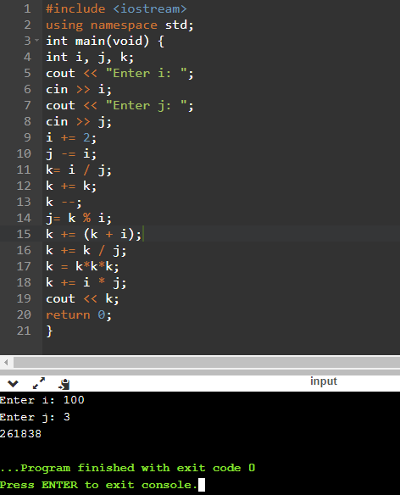

**Lab 1.6.1 Logical data: operators and expressions**

We need a number whose value:

* is greater than or equal to 0 and less than 10, or
* multiplied by 2 is less than 20 and reduced by 2 is greater than minus 2, or
* reduced by 1 is greater than 1 and divided by 2 is less than 10, or
* is equal to 111.

**Code:**

#include<iostream>

using namespace std;

int main(void)

{

bool answer;

int x;

cout << "Enter a value: ";

cin >> x;

answer = ((x>=0) && (x<=10));

answer = ((x*2<20) && (x-2>-2));

answer = ((x-1>1) && (x/2<10) ||x==111);

cout << (answer ? "THAT'S TRUE :)" : "THAT'S NOT TRUE :(") << endl;

return 0;

}

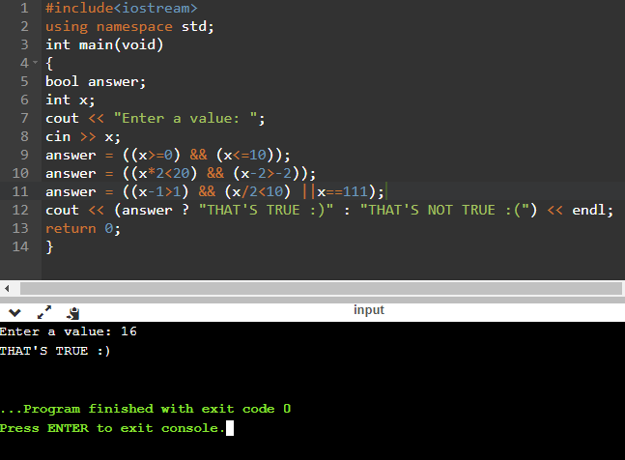

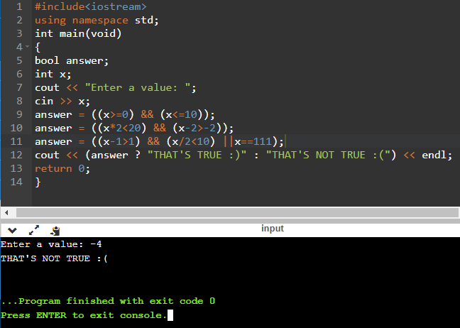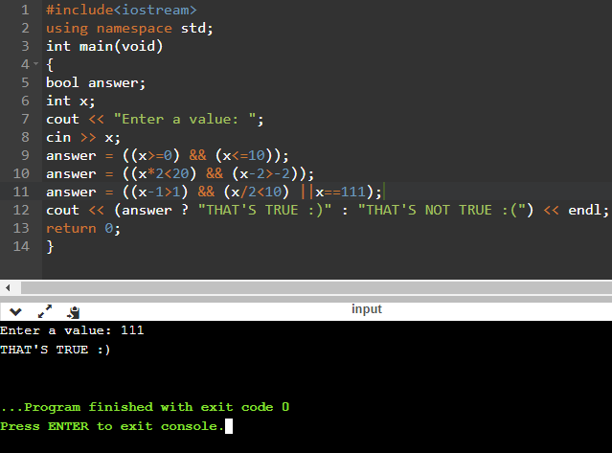

**Lab 1.7.1 Printing data**

Define five variables in your code. Assign the values from the input to these variables. Print these variables to get the specified output.

**Code:**

#include <iostream>

#include<cmath>

#include <iomanip>

using namespace std;

int main()

{

double a,b,c,d,e;

a=2.3;

b=2.3;

c=2.123456;

d=2.123456;

e=2.123456;

cout << fixed << setprecision(1) << a << endl;

cout << fixed << setprecision(2) << b << endl;

cout << fixed << setprecision(6) << c << endl;

cout << fixed << setprecision(2) << d << endl;

cout << fixed << setprecision(0) << e << endl;

return 0;

}

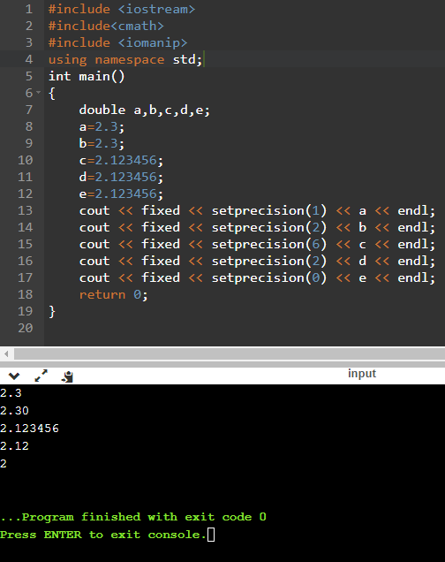

**Lab 1.7.2 Near zero float numbers**

Write code to check if two given numbers differ by only a small value (i.e.0.000001). Ask for two integer numbers from the user. Divide 1 by each of them (1 by the first number and 1 by the second number)and compare the results of this operation. Print the information to the user.

**Code:**

#include <iostream>

using namespace std;

int main()

{

double a, b;

double a1,b1;

cout<<"Input two number:";

cin>>a>>b;

double epsilon=0.000001;

a1=1/a;

b1=1/b;

cout<<"epsilon is: "<<epsilon<<endl;

if ((a1-b1)<=epsilon)

cout<<"Equal!";

else

cout<<"Not equal!";

return0;  
}

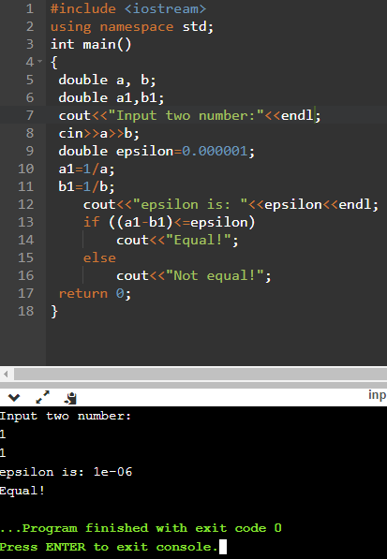

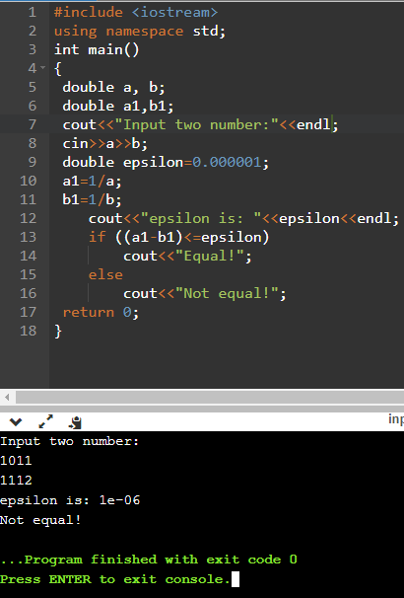

**Lab 1.7.3 Getting input from user**

Write a simple code to input an IP number. Check the given data with a few simple conditions (i.e. if the number is in the range from 1to 255) and concatenate it into an IP number. You must get four numbers from the user, connect them with dots and print them.

**Code:**

#include <iostream>

#include<cmath>

#include <iomanip>

using namespace std;

int main()

{

double a,b,c,d,e;

cout<<"Input 4 values(<255): "<<endl;

cin>>a;

cin>>b;

cin>>c;

cin>>d;

if(a<=255 && b<=255 && c<=255 && d<=255)

cout << a << "."<< b << "."<< c<< "."<< d << endl;

else

cout<<"Error.Your value must be < 255"<<endl;

return 0;

}

